<http://www.zoomnews.es/sites/default/files/images/201311/casa_gisele_bundchen_6.jpg>

hub

<http://store.storeimages.cdn-apple.com/4662/as-images.apple.com/is/image/AppleInc/aos/published/images/H/JE/HJE22/HJE22?wid=572&hei=572&fmt=jpeg&qlt=95&op_sharpen=0&resMode=bicub&op_usm=0.5,0.5,0,0&iccEmbed=0&layer=comp&.v=m3plz2>

ia

<http://iphoneros.com/wp-content/uploads/2015/06/nuevaonda.jpg>

---------

imagenes dispositivos compatibles

Yale

<https://s3.amazonaws.com/support-assets.nest.com/web_developer/catalog/production/5d8292d1cb7a9186022aa1b0cd1de233/94f396d3a954770404872edb7f583c38/426529ce-7761-11e5-87ba-22000b430e75.jpeg>

Amazon echo

<https://s3.amazonaws.com/support-assets.nest.com/web_developer/catalog/production/d821fb91620eb859ce7f7f1d19d88891/285c48d838d92b3f9adbdbb753d347c7/35d5c9bc-e731-11e5-8918-22000b430e75.jpeg>

whirlpool

<https://s3.amazonaws.com/support-assets.nest.com/web_developer/catalog/production/f8ef0826a08b6e1075c42a21794e8c06/c1b7526739ae3840afc18d0c39154d55/c1c7333e-7756-11e5-9c00-22000b2206b0.jpeg>

Filx

<https://s3.amazonaws.com/support-assets.nest.com/web_developer/catalog/production/00950605b0e4ee7e8ef0a4f80457867e/173df80152cddab7c84277b0a444beee/835d056c-c565-11e5-bdc0-22000b2206b0.jpeg>

Chamberlain

<https://s3.amazonaws.com/support-assets.nest.com/web_developer/catalog/production/5e1ec0e82b725f5c69b2c1d1b9ecb2bf/d521593d5b55271f908ec5c348084f52/43fe1ba8-831c-11e5-867d-22000b0b8590.jpeg>

greenIQ

<https://s3.amazonaws.com/support-assets.nest.com/web_developer/catalog/production/f12779670cc4ec6552a75531b7428f8a/51f085324ca0edf42b95d8873b8a7531/e946aaf6-e92b-11e5-afa6-22000b430e75.jpeg>

hue philips

<https://s3.amazonaws.com/support-assets.nest.com/web_developer/catalog/production/7565da55817ad2ebe84273c64ef92150/d51795c625dbb74d144dcc2b4acce734/6593b8f2-88b9-11e5-a00f-22000b02962c.jpeg>

bigass

<https://s3.amazonaws.com/support-assets.nest.com/web_developer/catalog/production/7449f4649297e06afd01f27cf8aeee77/c0525bc336b18e315a25b21f780d87b9/88398b3e-83e6-11e5-b98e-22000b02962c.jpeg>

Rheem

<https://s3.amazonaws.com/support-assets.nest.com/web_developer/catalog/production/2f9c583d4fe266f790e6b91e42cfb613/f9bdb34cb233307ea8e7f815cb8fa612/751a2fe0-b8a2-11e5-84a5-22000b0b8590.jpeg>

petnet

<https://s3.amazonaws.com/support-assets.nest.com/web_developer/catalog/production/a8ce590ba74c7e4ed26a233291aa1e60/45dbe973f7367393f6d41592dcf0e270/663c00cc-88a8-11e5-bc0c-22000b0b8590.jpeg>

----

imagen app

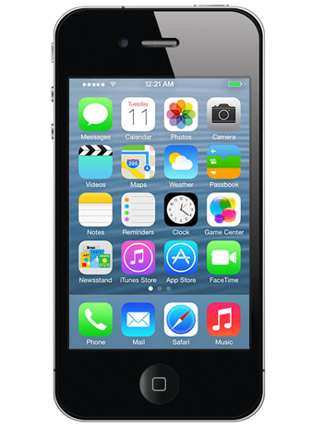

<http://assets.recommerce.com/mobiles_MD/805861b90.jpg>